Much Ado about Mothing - and other creatures

Much Ado about Mothing is a book by James Lowen that I was given for Christmas but am only just finding time to read! I think you need to be quite interested in moths to read it, but I’m thoroughly enjoying learning about moths I’m never likely to see for myself. James recounts a year spent travelling across Britain in search of the rarest of moths. But, alongside that, James and his young daughter track the seasons through a kaleidoscope of moth species living innocently yet covertly in their suburban garden. Without even leaving home, they bond over a shared joy in the uncommon beauty of common creatures, for perhaps the greatest virtue of moths, we learn, is their accessibility. Moths may be everywhere, but above all, they are here. Quite unexpectedly, no animals may be better placed to inspire the environmentalists of the future.

And ‘here’ for me is Trusham Churchyard where records of moths and all invertebrates plus any living plant, lichen, fungi or creature is recorded. By 4th May I had reached amazing new heights because I’ve managed to identify (or find some expert to identify) a total of 601 invertebrates of which 304 are moths. I had never have dreamed of reaching those sort of totals! Here are some of the latest sightings.
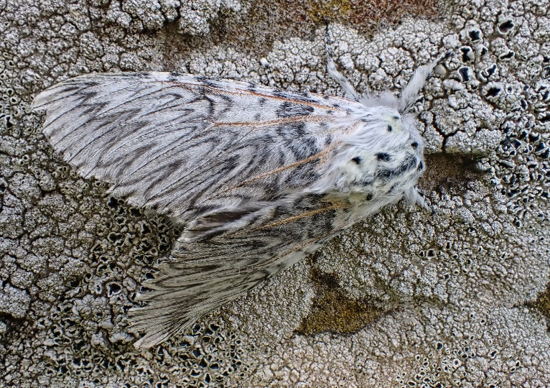
The amazing Puss moth - do look up what the caterpillar looks like https://butterfly-conservation.org/moths/puss-moth - it’s stunning.
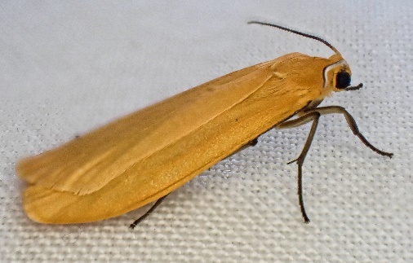
I’d never seen the moth before and there were three attracted to the actinic lamp moth traps on 1st May.

There’s a small group of moths called Footmen but I’d never seen the Orange Footman before - plain, but stunning.
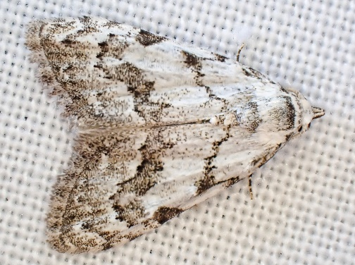
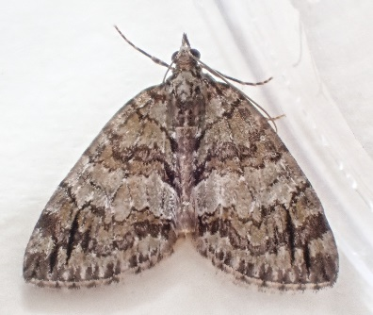
What else that day? Well, the aptly name May Highflyer. It may be a little brown moth but is quite distinctive when you get your eye in. The larval food is Alder and I’m not aware of any near Trusham Church though there may be some along Bramble Brook in the valley below the church.

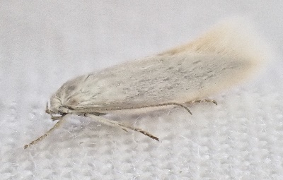
The Least Black Arches (R) is very small but distinctive. But one of the smallest moths on 1st May was the Elachista argentella (R) (a Swan-feather Dwarf). In total The moth trap on 1st May produced 133 moths of 56 different species, 12 of which were new to the site.

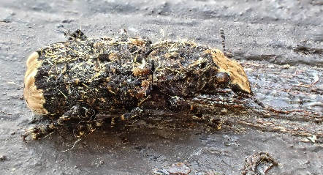
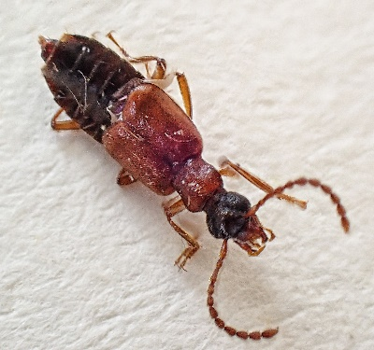
But we can’t let the moths steal the limelight. Indeed, when you set up a lighted moth trap you often get what are called ‘Moth Trap Intruders’ and they can prove to be just as exciting as any of the moths. That night we had eight other invertebrates, three of which were new species for the churchyard.

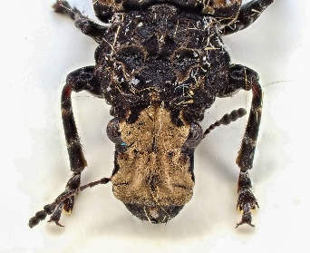
This beetle (R) is Deleaster dichrous. But the strangest creature I’ve ever found (L) is this Scarce Fungus Weevil. It’s not quite as scarce as its name suggests, but it’s not common! It’s like a small bit of twig but sounds like a pebble if you drop it, it’s so hard!

So there you have a few of the latest Invertebrates to be found in Trusham Churchyard. And almost every time I go up there I find something new. It keeps reminding me that we must look after our land. I don’t need to tell you that It’s teeming with incredible creatures which rely on us to maintain our spaces for the benefit of wildlife.

