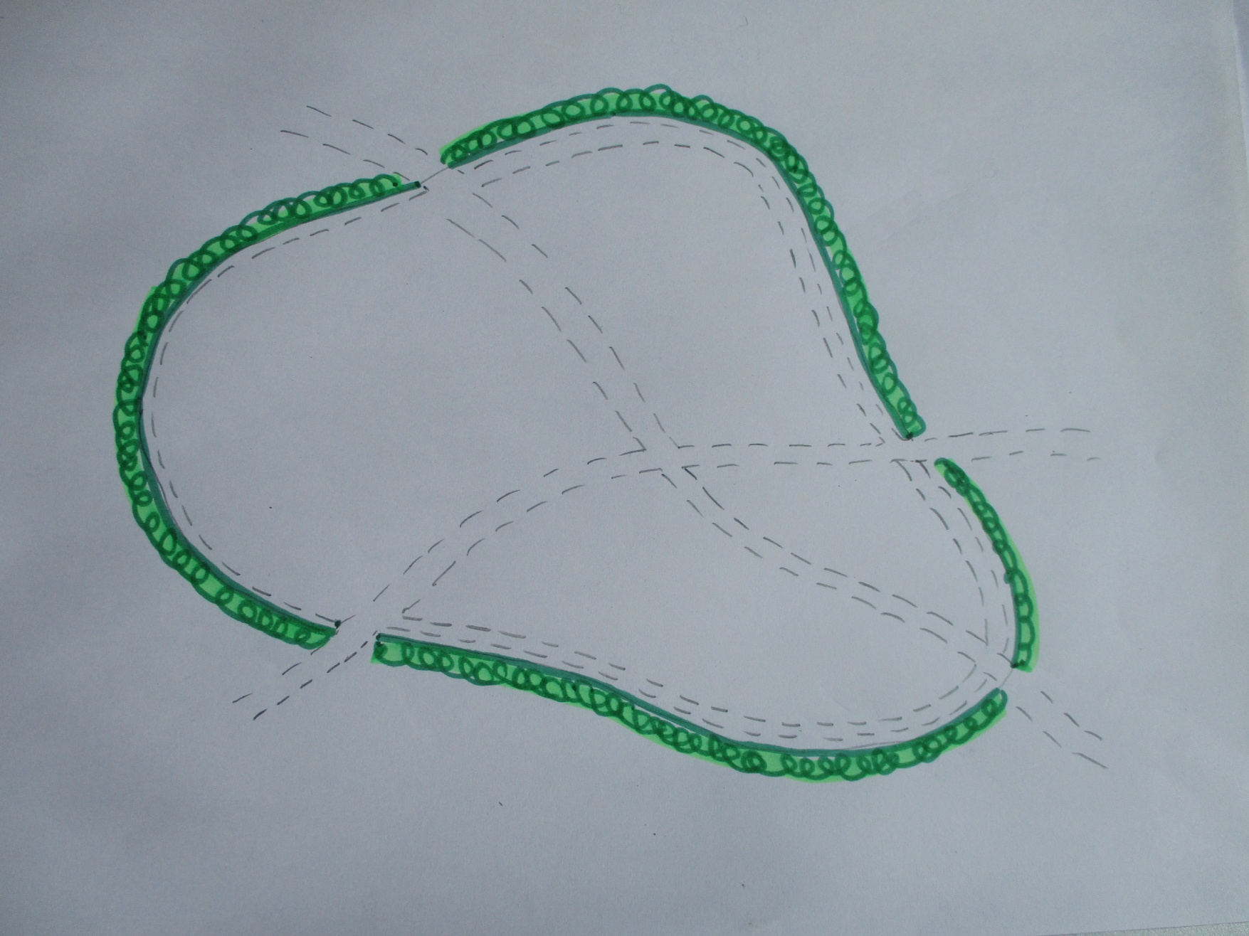

Diagram 1:
Here is a small public open space, which isn’t heavily used.
- It has a hedge around it.
- Up until now it has only been cut in the Autumn; the informal paths are worn into it!
      - There are plenty of dandelions and a few other wildflowers – but it’s mostly grasses.

It has been decided to try to increase the wildflowers and insects, without it being too time-consuming.
The best species-rich pastures are often those grazed by cattle; cattle graze in a rather random way, wandering around and eating patches of grass.
You can’t put cattle in the area – but you CAN mow like a cow!

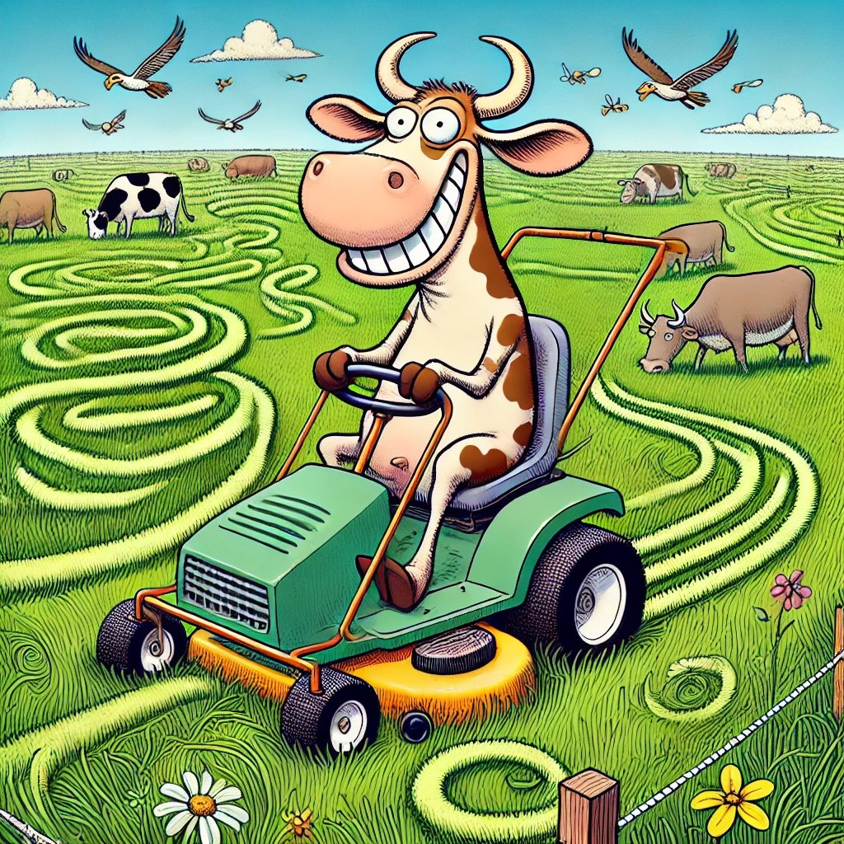
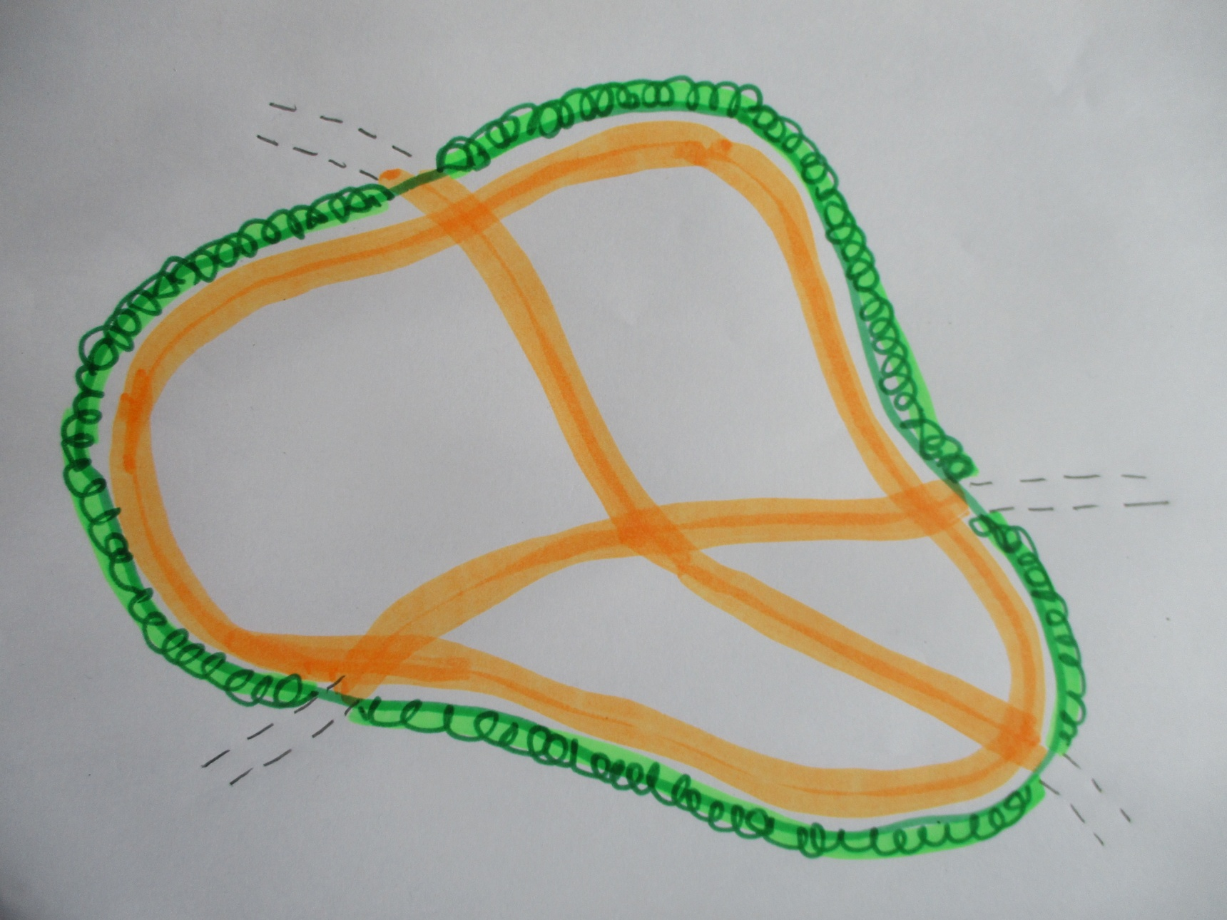

Diagram 2:
It’s May, time for the first mow of the year. Nothing to do with wildlife but mow the paths that people have already made – they will love you!
- Mow them wide so that people can pick up dog mess easily and to reduce muddy patches.
- Mow around the hedge (about 1-2 metres out) to make another good walking route.
But you haven’t finished yet!!!

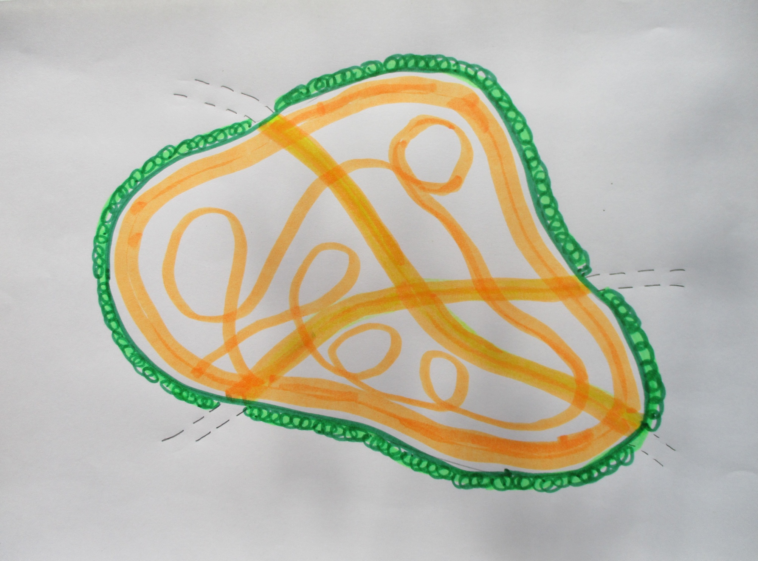
Diagram 3: Now go a bit mad and spend the next 10 minutes mowing squiggles – be a bit random!
That’s it! Off to the next site…

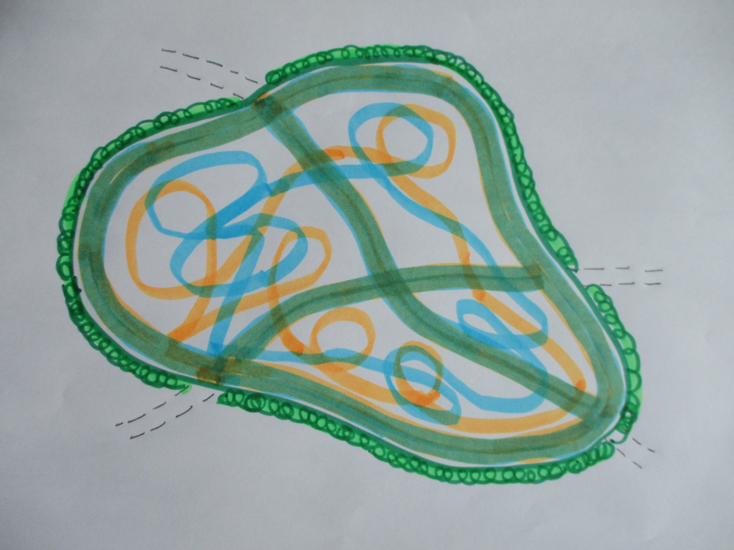
Diagram 4:
It’s July and you’re back!
- Mow the paths again and mow around the hedge line.
- Then have a bit of fun – do some different squiggles!
- If there are any special flowers in bloom, you can avoid them.
- But apart from that, spend whatever time you’ve got left squiggling – or is it scribbling?
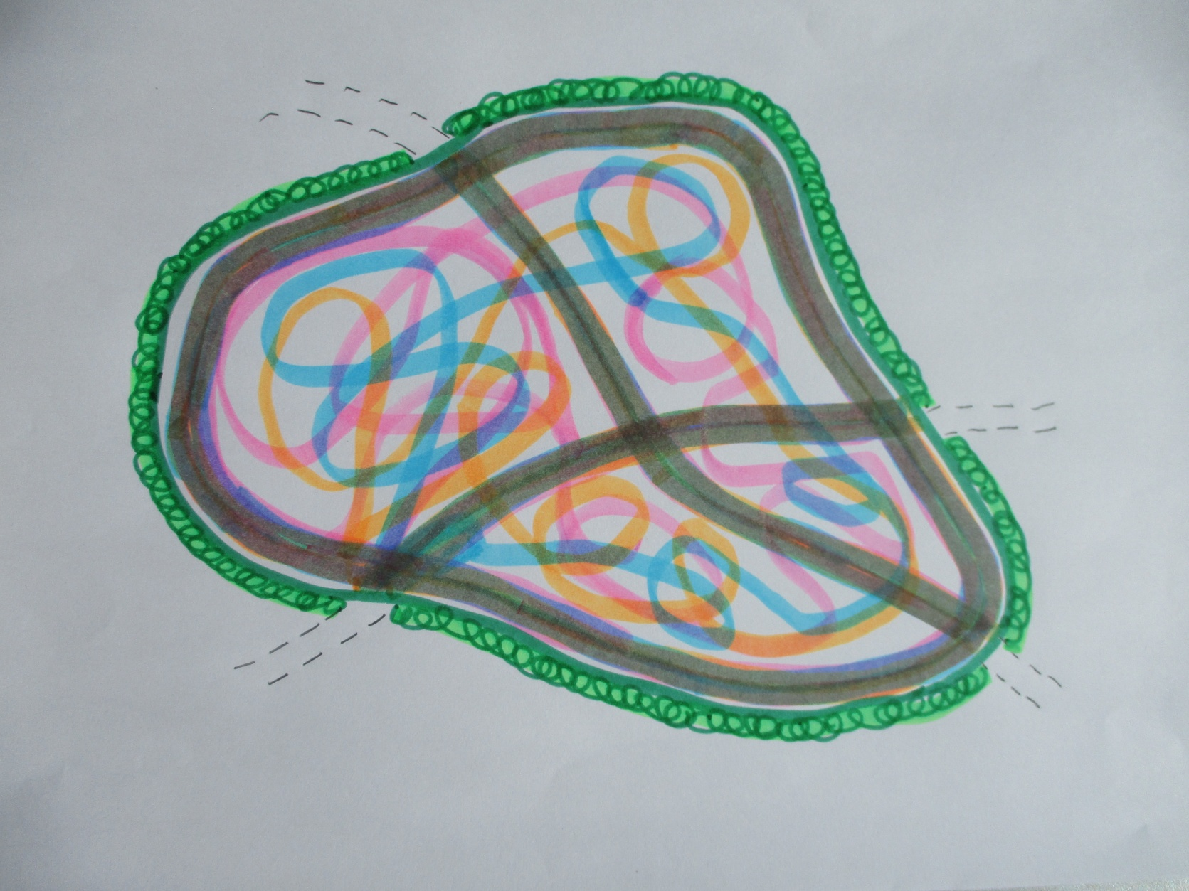
Diagram 5: It’s August ….
- Maybe there is a drought, and the grass hasn’t grown much.
- Maybe there’s been a monsoon and it’s up to you knees!
- Whichever, repeat what you did in July – but do some different squiggles.
- If you are lucky, there may be some flowers and butterflies around – but if there aren’t this year, there might be next year.
Random mowing works well on most grasslands – but the idea has to be introduced carefully, as most people HATE change – and lots of people HATE anything untidy, even if there are pretty flowers and beautiful butterflies to enjoy! You don’t want complaints….

